Requirements for Portflow Evidence Section

A system where students can create and maintain a structured portfolio.

* A student can add multiple kinds of evidence:
  + LMS assignment submissions - imports of submitted assignments from courses in the LMS,
  + File uploads - can be any type of file, with a max size of 500 mb per file,
  + Links
  + Free text - to create evidence quickly and directly without the need for a local text editor,
  + Video - embedding video from popular video platforms (YouTube, Vimeo),
* Common file types (e.g., .docx, .xlsx, .pptx, .pdf, .jpg, .png, etc,) should be preview-able directly,
* All files can be downloaded from the portfolio,
* Evidence can consist of multiple files per evidence,
* Evidence can have multiple versions, with multiple files per version (feedback is tied to an evidence),
* Evidence can have a name and rich-text description / reflection,
* Evidence can be @mentioned everywhere in the portfolio, generating an active link to evidence,
* Evidence can also be a reflection,
* Evidence section has a search bar,
* Evidence needs to offer goal and collection edit,
* Goals per evidence should be visible too (just like collections) in evidence section overview,
* Filtering of evidence by date, type of evidence etc.,
* Visible feedback status per evidence (request, pending, feedback received or sth alike),
* Evidence should be arrangeable or orderable by type, date,
* Should be possible to upload evidence from google drive,
* Bulk delete options,

Evidence Dashboard

The features to be added to dashboard in order to improve the current state.

* File map can be used to show where the file is within the structure (tree) or card system to group ‘em,
* Rename the Section to just “Evidence” or “Evidence management” or “Evidence Panel”, ❌
* Option to change view to:
  + List
  + Icons/Cards
  + Detailed list
* Option to sort the contents by: (Date-created is default)
  + Collection
  + Goal ❌
  + Type
* Group by:
  + Collections and their content,
  + File types
  + Goals and their content ❌
  + Course (when uploaded as canvas assignment) ❌
* Filtering (via search field and/or buttons) by
  + Date (from-to)
  + Name
  + Collections
  + Goals
  + Type
* Display evidence details on hover or in a separate section:
  + Name
  + Type
  + Upload date
  + Linked Collections
  + Related Goals
  + Feedback status
  + Comment count
  + Evidence Description
  + # Versions
* A preview section for a faster file management, ❌
* There should be a counter of evidence when filtered,
* Option to remove evidence:
  + One by one
  + Bulk

Create several versions: start with basic idea and add only a few main features (v1), others make more complex: use cards (v2), use a tree (v3);

V1: use existing list view but add + sort by collections, goals, type + display goals and collections and option to edit them + latest feedback status, comment count, # of versions and total feedback count.

V2: card system + details section with goals and counts of comments and feedback etc + duplicate evidence + drag and drop evidence.

V3: tree system of all evidence + no clue, think about it…💭

Perhaps goals and collections can be linked and displayed using below for ideas:

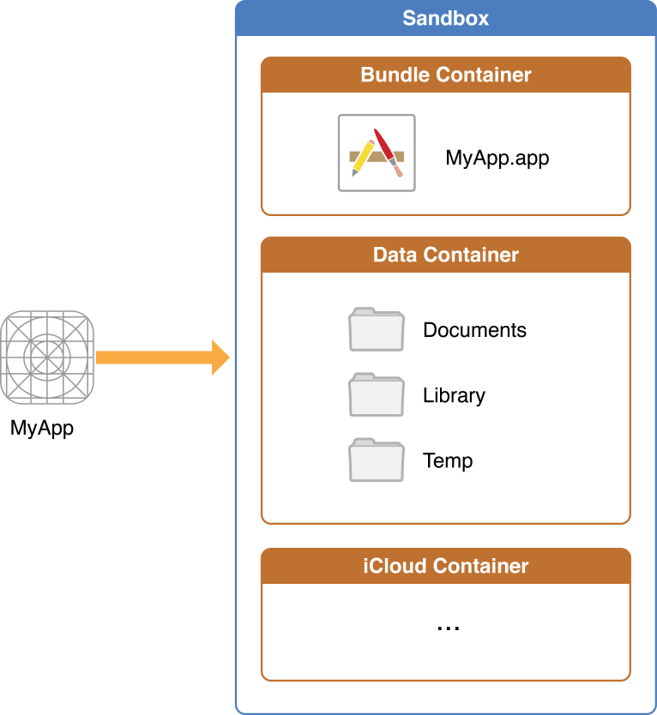 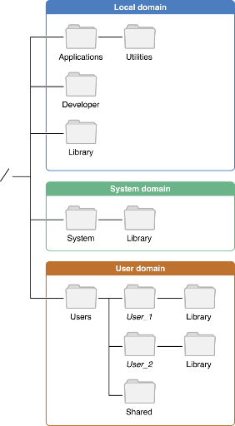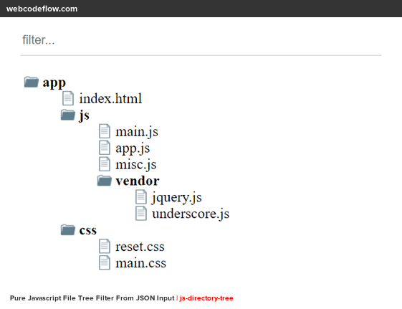

V4: Pieter’s version (combination of cards and list) use a dashboard (control panel) to filter and sort the table below)

V5: Smart Table by antDesign – it can offer same features and more, also combine different filters + add stats summary based on filters applied.

V6: Dashboard with a smart table, for dashboard use StudyCoach Dashboard as inspiration.

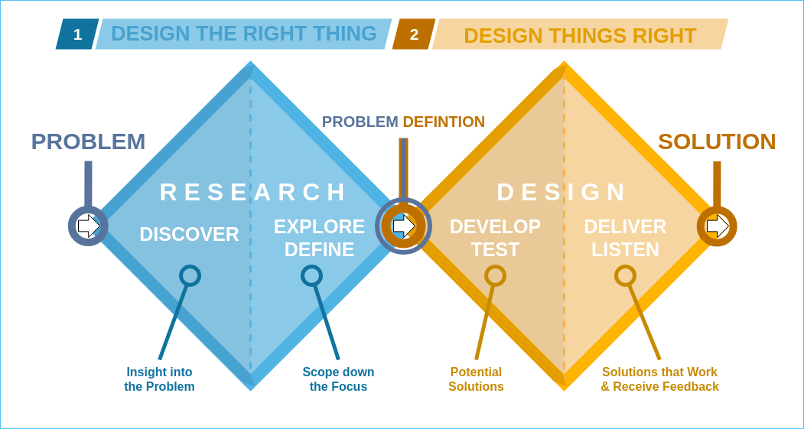

Defined the problems and scope in requirements document (refinement too)

Design diamond happened twice, made first 3 versions, after feedback concluded to one (V4).

Then, received feedback again and diverged into 2-3 more versions again (V5 and V6).